**PROCESSING AN EXCISE TRANSACTION**

1. Compare the information on the deed to the information in PACS for the parcel.
2. Look up Parcel/Geo #

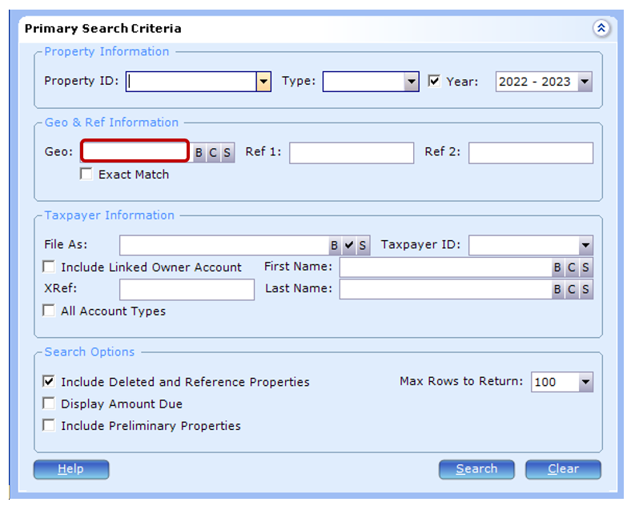

1. The first thing you will check GROUP CODES: if the property is flagged for **PENDING BLA, PENDING NEW PLAT** – **DO NOT** process any deeds with these group codes – file the deed into Clerical/Deed Technician/BLA folder (segregation will sort them out and process what is ready to be processed) **you don’t have to file deeds for Group Codes for NEW PLAT.

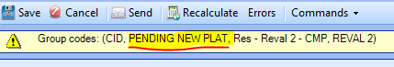 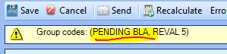

1. **CHECK LEGAL or PENDING ASSESSOR IN REVIEW**. –This mean a previous deed needed to be corrected and re-recorded. Check if new deeds of correction been record.  
    
2. Also, on this screen you will want to check and see if this parcel is exempt. If it is, you will want to save a copy of the deed to the respective folder. If it is an EX(DOR) or Exempt parcel, you will save a copy of the deed to the Government Transfer folder, and if it is a Senior or Disabled Exemption you will save a copy of the deed to the Senior-Disability Exemption Transfers folder located at G:\Clerical\Deed Technician. Example name of file: 107982130000046 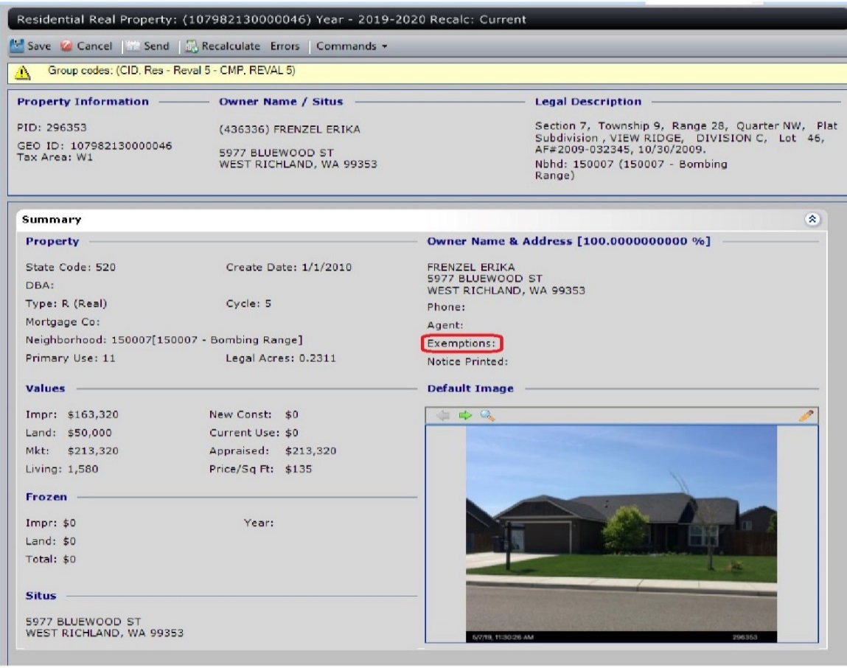

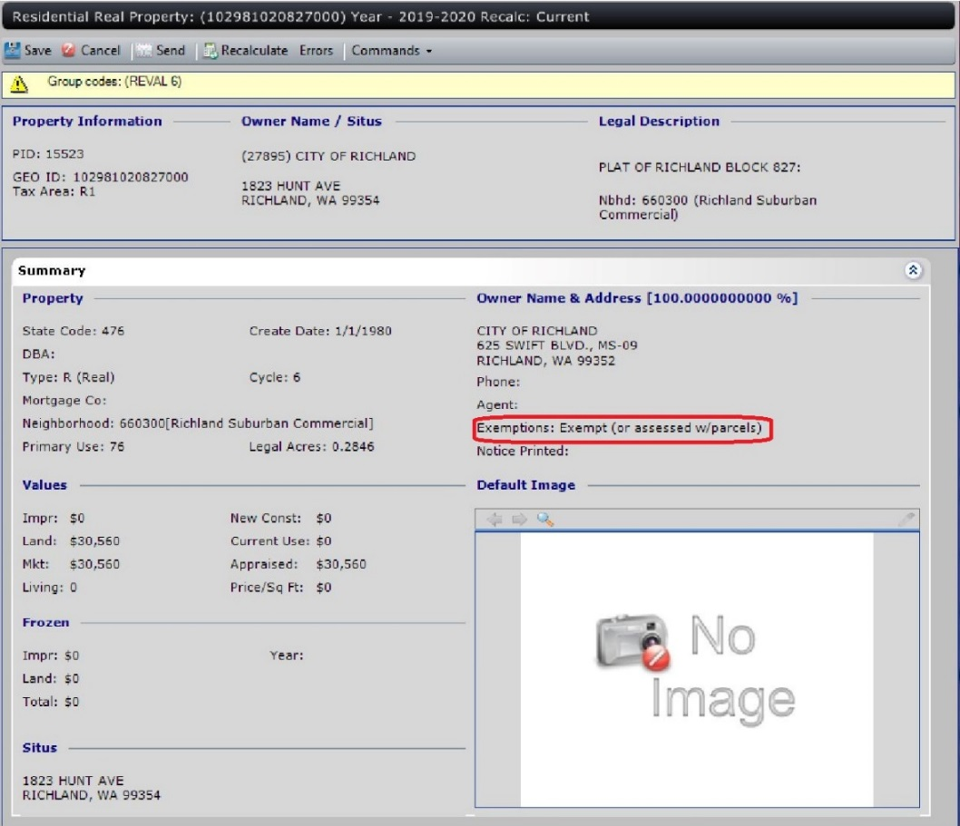

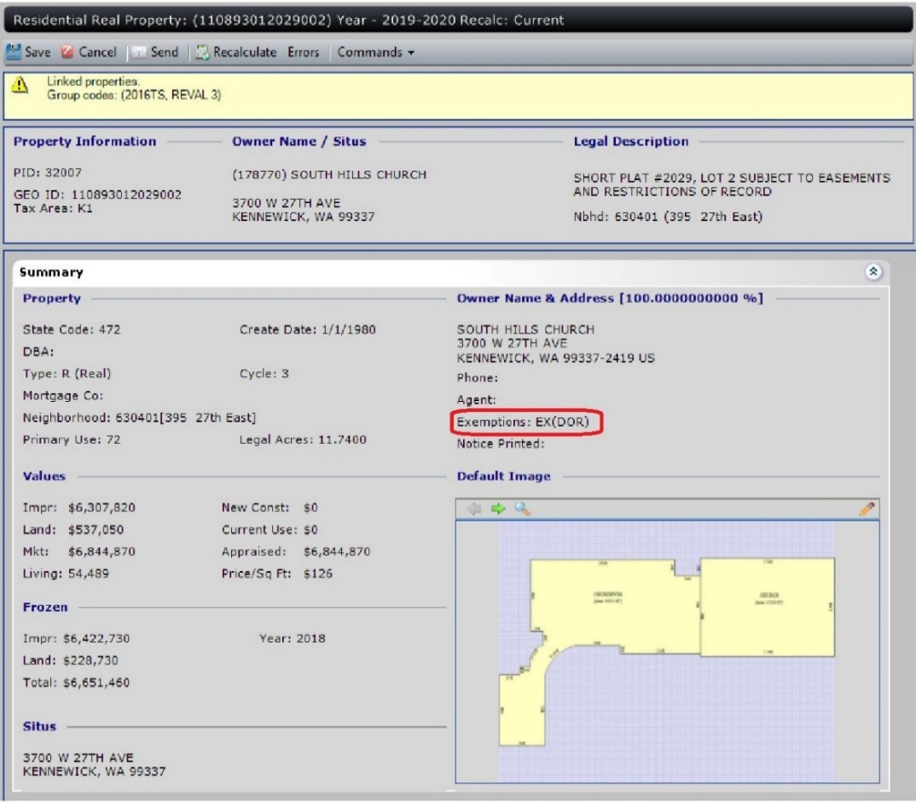

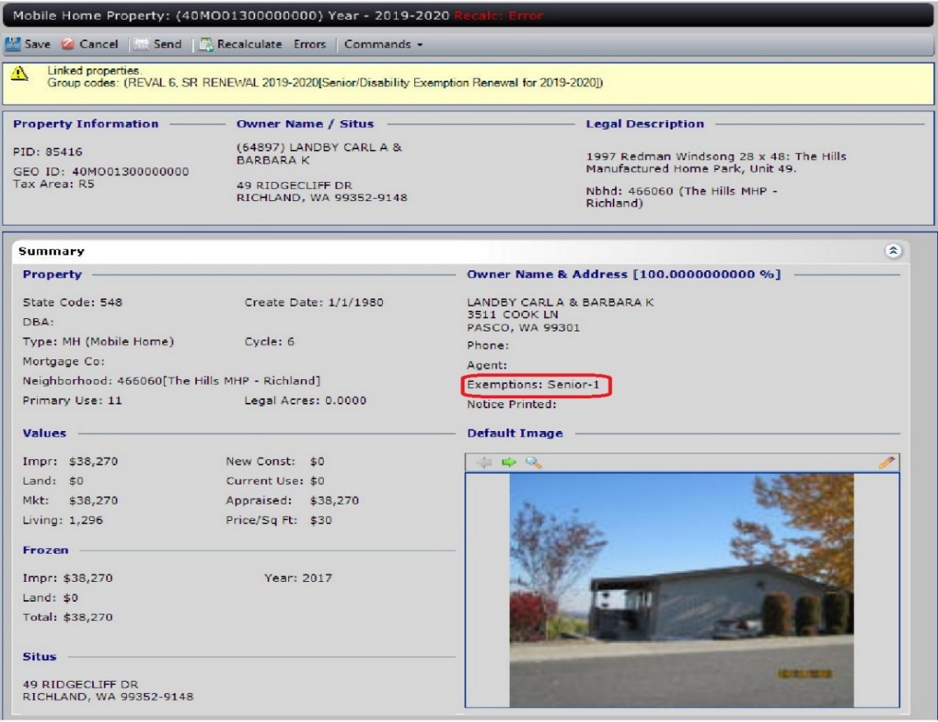

1. While in the Summary panel, if there is no value in the Impr field under Values, note on the side of the deed copy that this is ‘land only’. This will be entered in PACS later in this process.
2. Under Default Images:  Verify mailing address on the excise – match the excise on the deed.  
    Mailing Address located BOX 3 – if empty than BOX 2  
   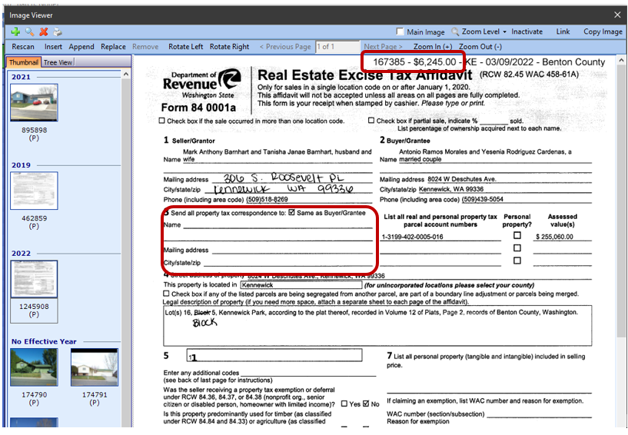
3. On Legal Description Panel, verify the Legal Description matches the deed legal description. Be aware that the full legal description should be verified, not the abbreviated legal.

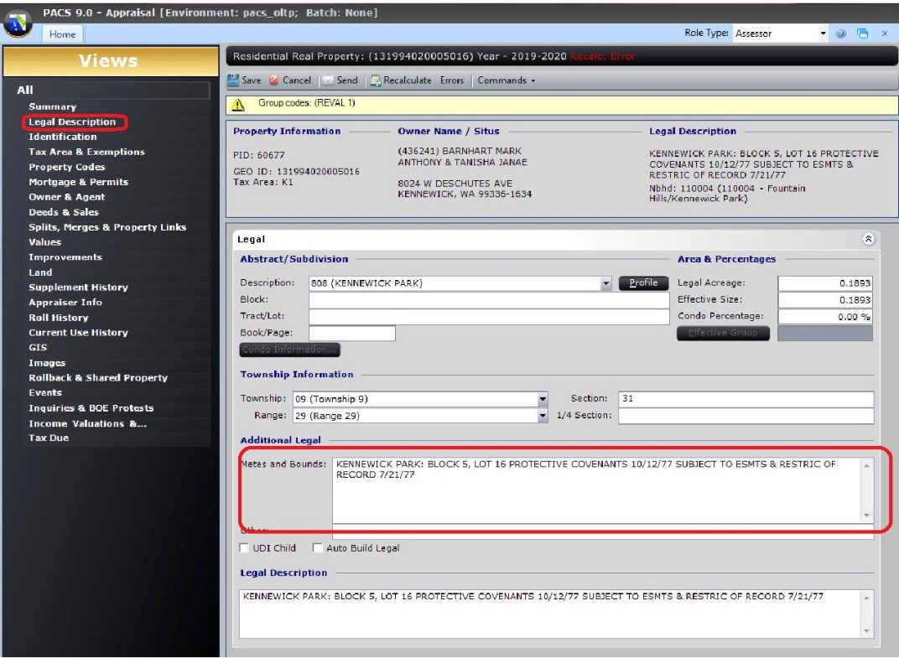

* 1. If wrong/doesn’t match, send the deed to the segregations department to verify. You do this by saving a copy of the deed to the Check Legal folder or to the BLA folder located at G:\Clerical\Deed Technician. If this is the case, the deed will not be processed. Proceed to Exhibit A, step 2.

1. On Owner & Agent Panel, Verify Grantor’s name(s). Make sure it matches the deed. If the name(s) doesn’t match or it is missing an owner, the deed will have to be corrected before ownership can be transferred.

*Note: If it’s a Quit Claim Deed and a spouse releasing their interest and they are not listed on the ownership OR a linked owner – this is where you will change their name to reflect the deed.*

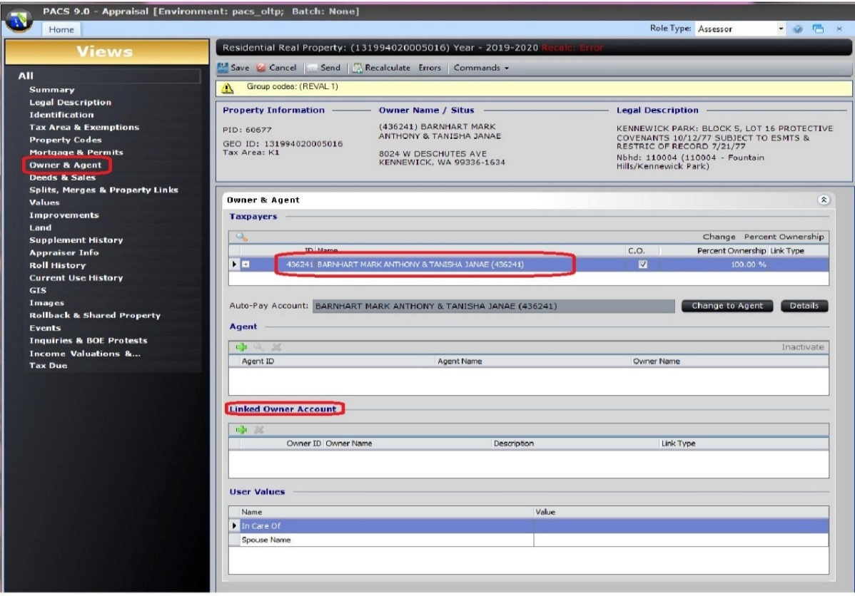

*Note #2: if you are going to click into the owners screen to modify…. Please be sure to check “properties” tab – this will let you know on how many properties are attached to this OWNERS ID#- if you were to change anything – this will change on all of them (see example bellow)*

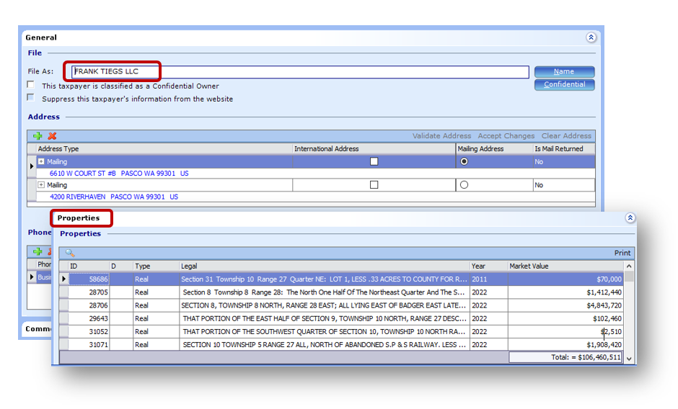

1. On Deeds & Sale Panel, Verify Excise number matches the deed. Click Transfer Ownership and the ownership transfer wizard will pop up.

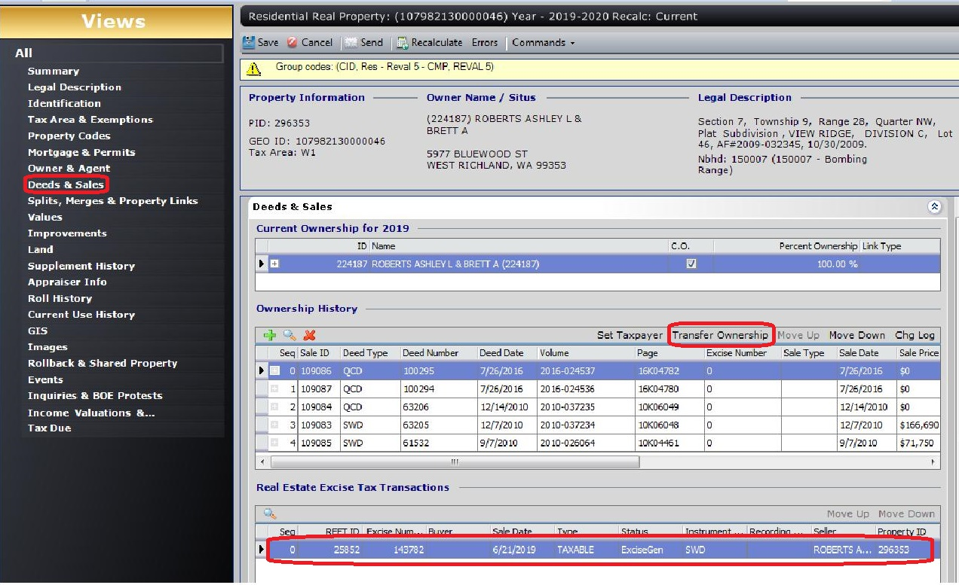

1. If there are multiple REETs, make sure the excise you select in the wizard matches the deed you have in front of you. ALL the excises have to be processed in order. *Note: if there is prev excise that haven’t been transferred – please look into it/that needs to be transferred 1st*. (if it’s a MH you are ok to transfer your deed) Click Next.

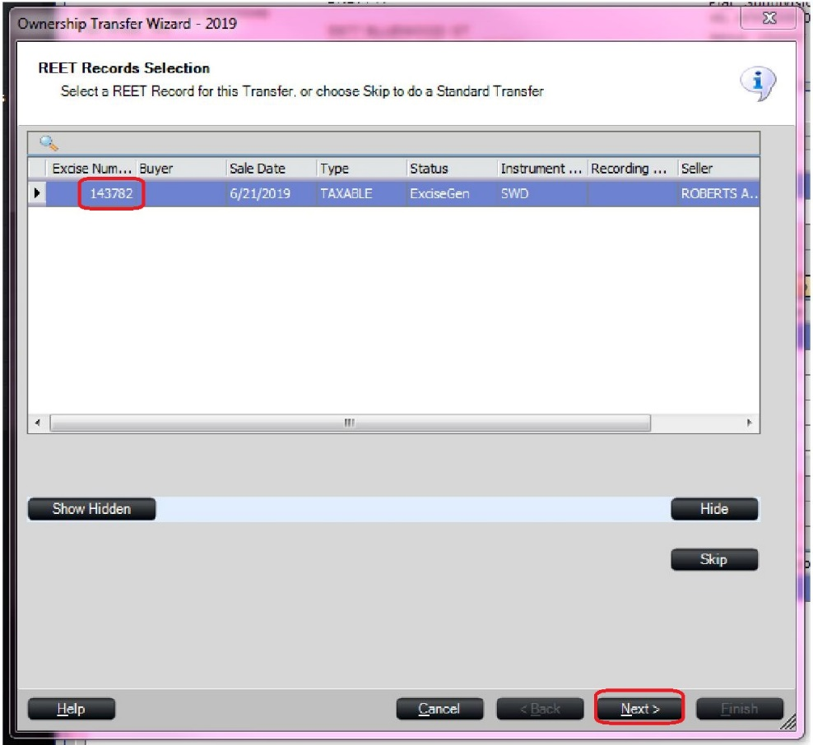

1. The seller name should automatically populate and should match the Grantor on the deed. Click Next.

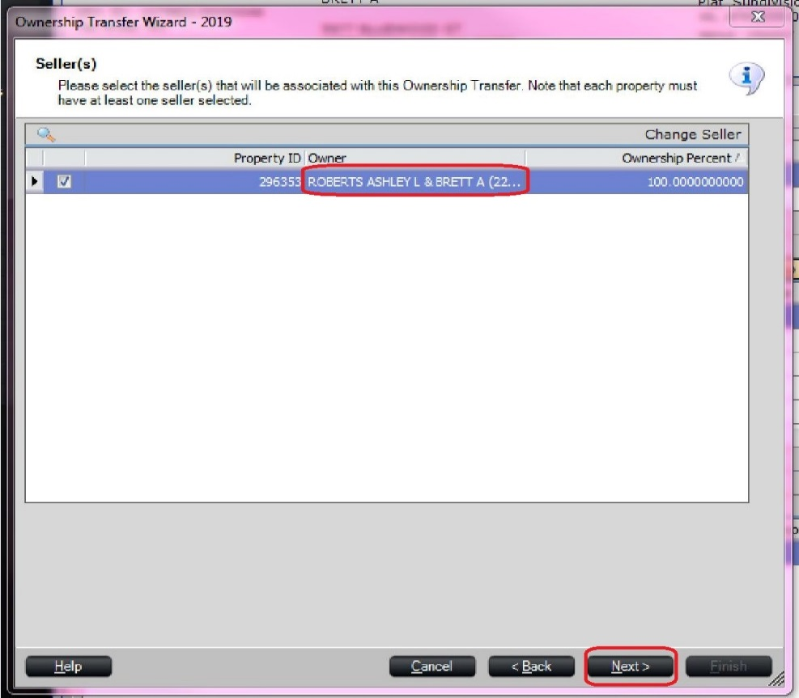

1. This screen is where you add the buyer/grantee.
   1. There are occasions when a buyer will be an exempt entity. If you believe this is the case, save a copy of the deed to the G:\Clerical\Deed Technician\Government Transfers and name it by the parcel number. Exempt entities include but are not limited to federal government (Department of…), state government (State of Washington), cities, churches, service organizations, cemeteries, housing authorities, schools, hospitals, public utility companies.
   2. Click Search and in the File As: box type in the last name or business name of the grantee. Click Next.

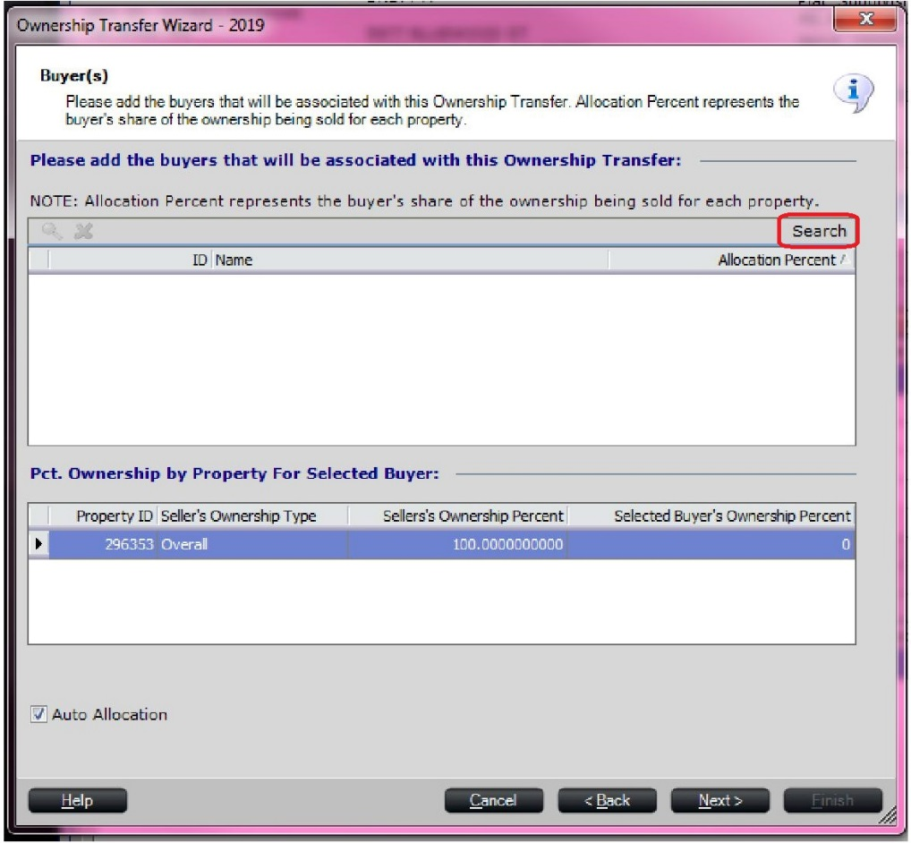

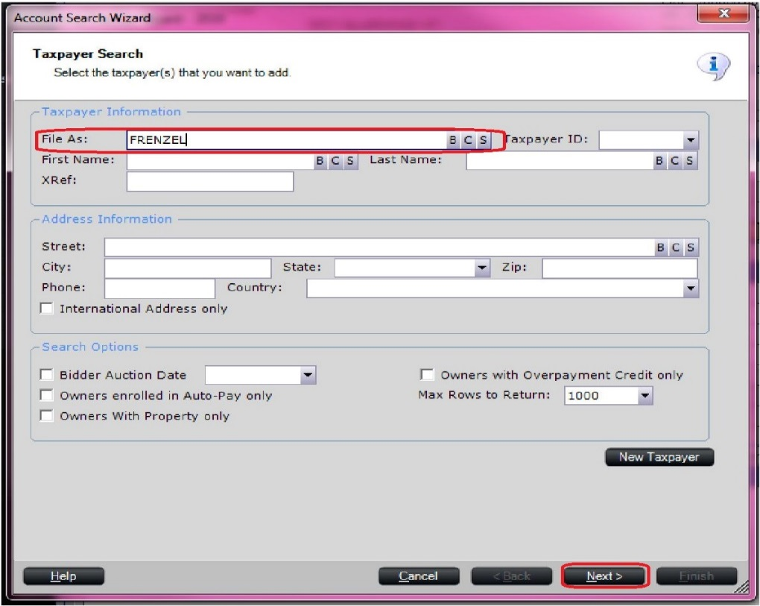

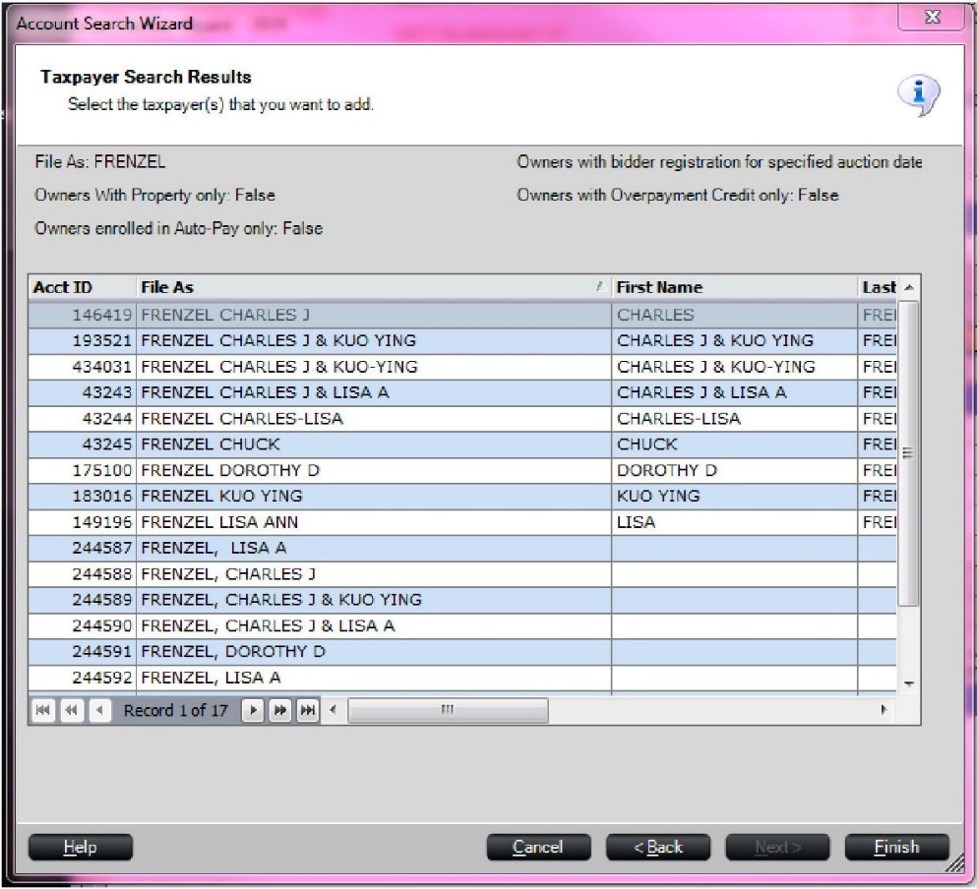

1. If you find a result that is the exact match to the names on the deed (this includes middle names/initials), select it and click finish. If there is not an exact match, click back. If you have clicked back, you will need to create a New Taxpayer. Click the New Taxpayer button and another screen will pop up.

*Note: Keep in mind that owners can own multiple properties under the same name with having different mailing addresses. Please select owner with OWNERS ID to match the mailing address on the excise. If mailing is different and you will need to go back to change it BUT will change for all the properties (OR you will need to create new owners id with new mailing address.) Be sure to select proper Owner ID. (We are trying to avoid creating new owner id’s – like this one below)*

1. 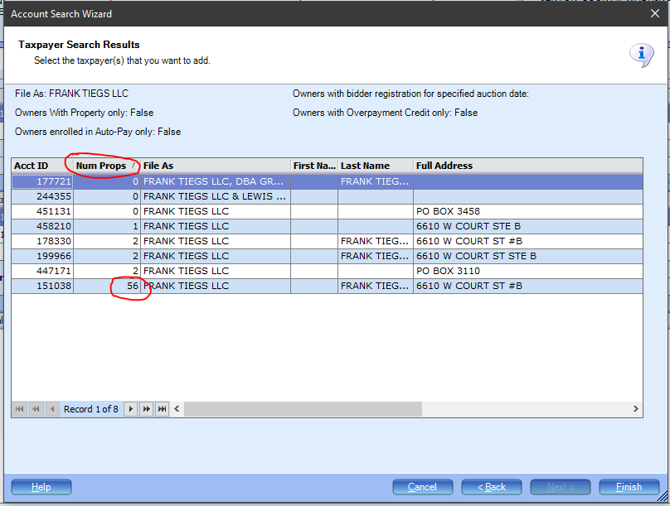

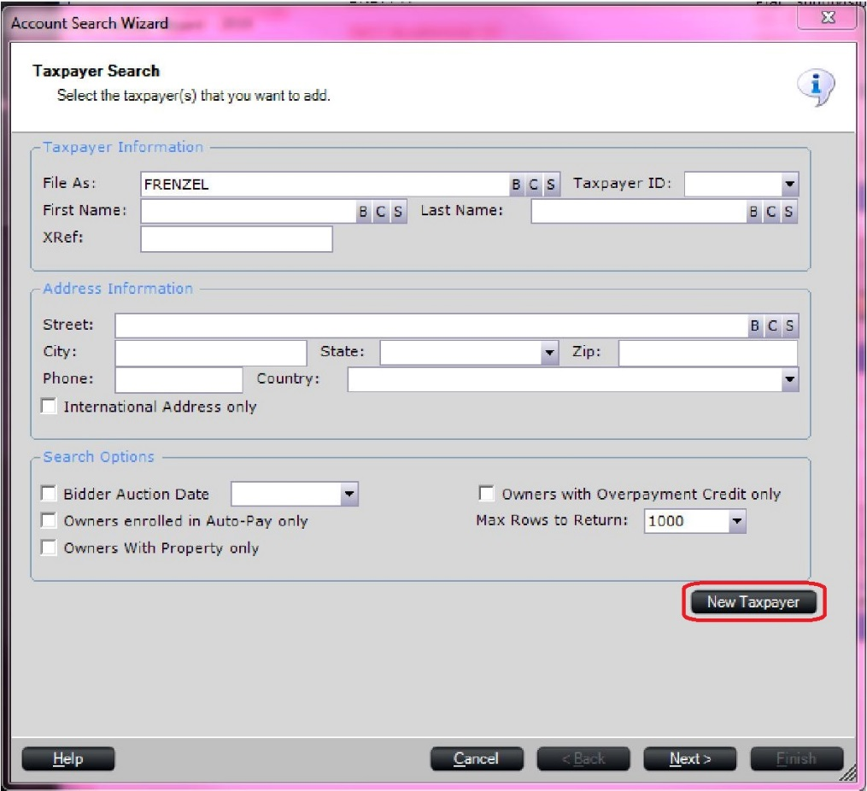

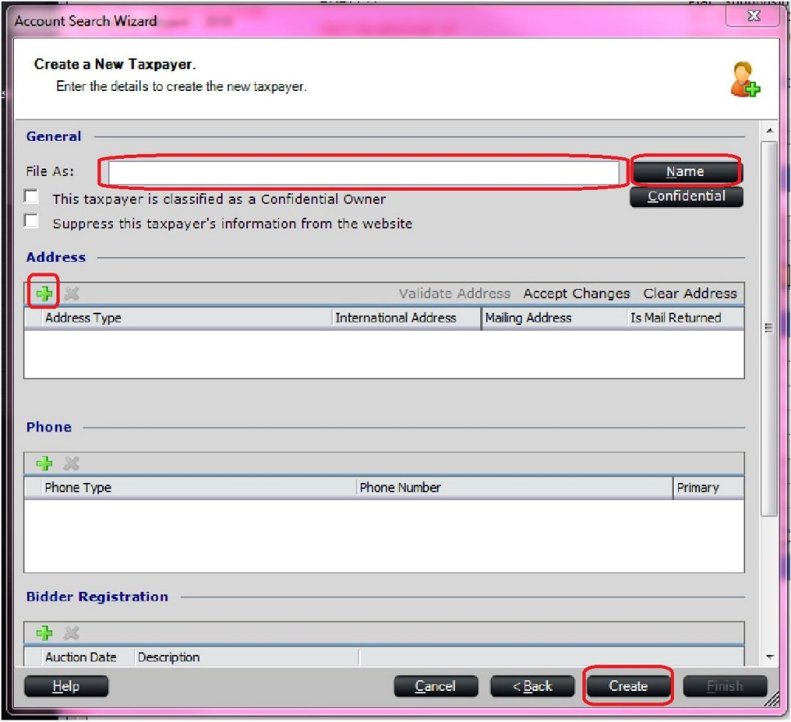

1. In the File As: box, type the Grantee’s name(s). Last name first then first and middle name or initial without any punctuation in all caps.

**Example:**

1.Two individuals as single with same last name, OR family member: SMITH JOHN A & SMITH LORI

2.Husband and Wife with same last name: SMITH JOHN A & LORI

3. 3+ owners – Try to limit to Two owners per OWNER ID: and the rest are lined as linked owners  
4. If wife keeps her maiden name and a new last name: SMITH JOHN A & SMITH RAMOS LORI

5. Owner with multiple last names: MENDOZA MARGARITO RAMOS & DE RAMOS LAURA VAZQUEZ  
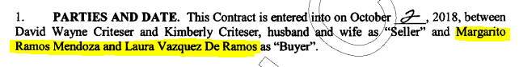

6.When ownership is in the TRUST: SILVERS TRUSTEES THOMAS G & JUANITA R (if they don’t have the name of the trustees – the deed needs to be rejected)

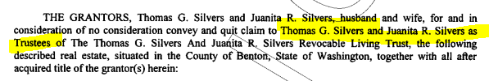

7. When ownership is listed under LLC and deed mentions DBA, we will only include LLC name – leaving out the DBA

Owner: **AAA Renovation & Construction LLC**

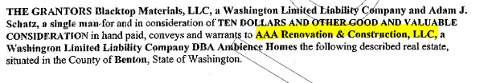

8. **BARNES JR PETER STIRLING (JR, II, III, IV)** will always go after last name.

1. Next click the Name button, click yes to save changes, then fill in the first and last names and click OK.   
   if last names are different – pick the last name of the 1st person listed.

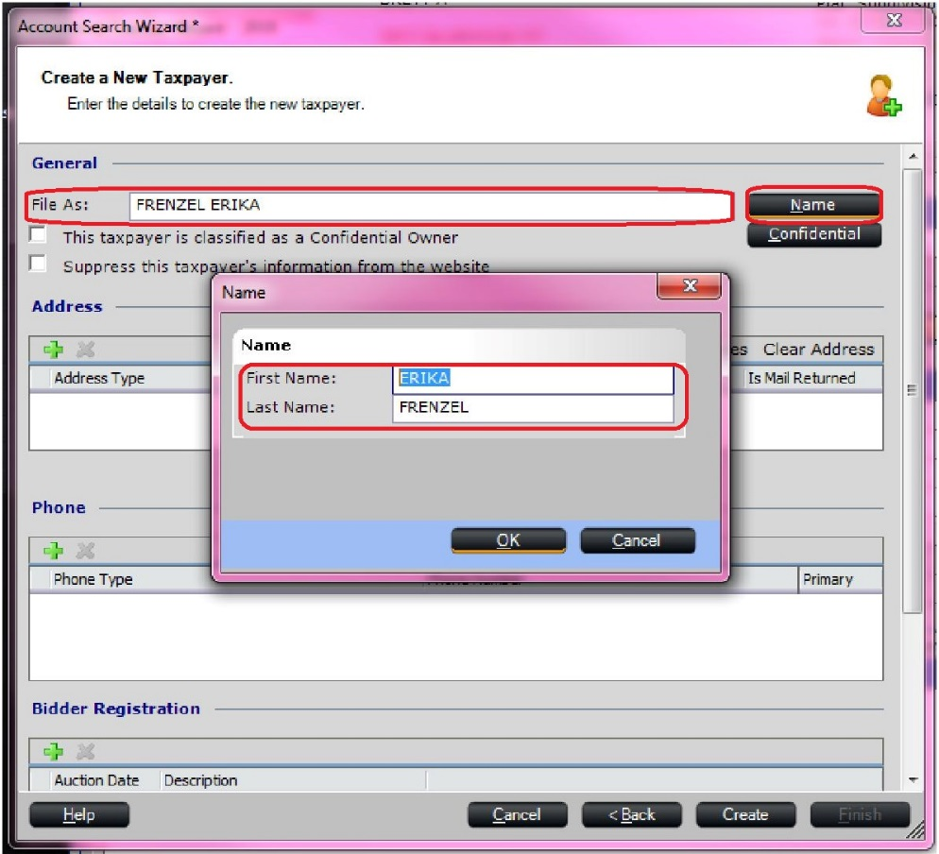

1. Next, click the green plus sign under the Address section. A new segment will show up in the Address box. Click the drop down arrow and select M(Mailing). You will find the Grantees mailing address on the Excise Affidavit, found in the Images panel on the parcel. You will need to open another session of PACS to view images. OR you can verify prior mailing to processing this deed. Enter the information in the respective boxes and then by Change Reason type in Deed. Click Create. Click Finish.

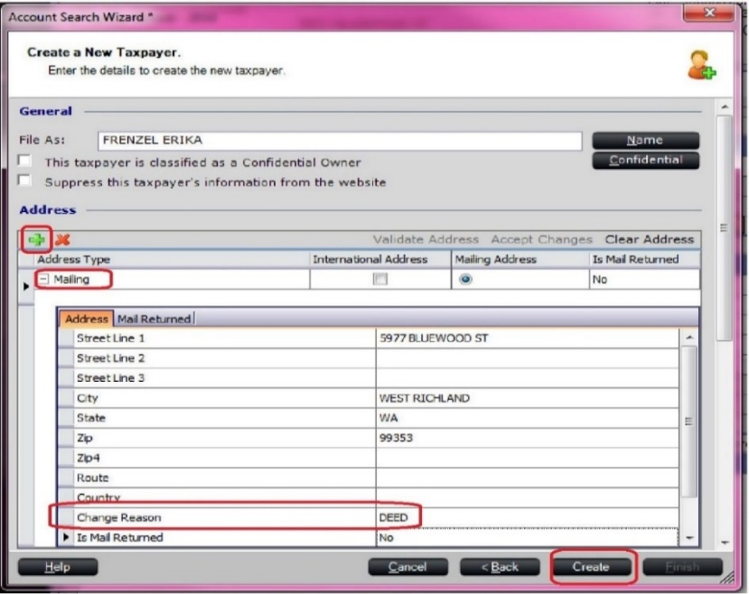

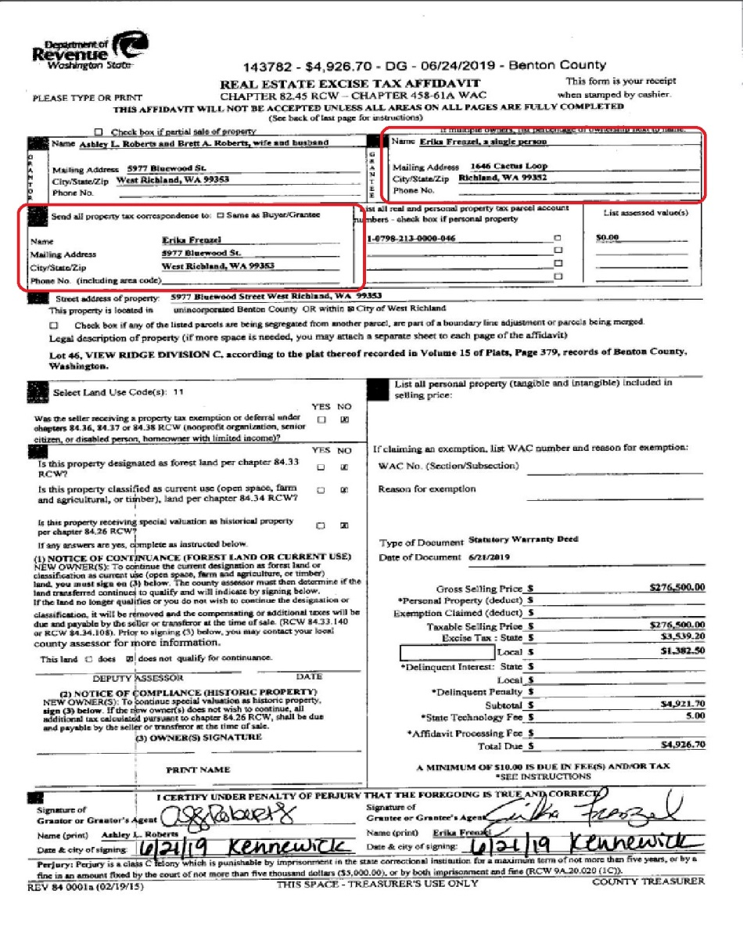.

1. Now the Buyer information should be correct, and you can click Next
2. The Deed Information screen is next. The Deed Type should already be populated, click tab, fill in the Book ID which is the Auditor File number on the deed. Then tab to the Recorded Date which is the date under the Auditor File number on the deed. If there are any comments needed this is where you will leave them (if you forget, you have another chance on a later screen to add them). Click Next. Click Next. Click Finish.

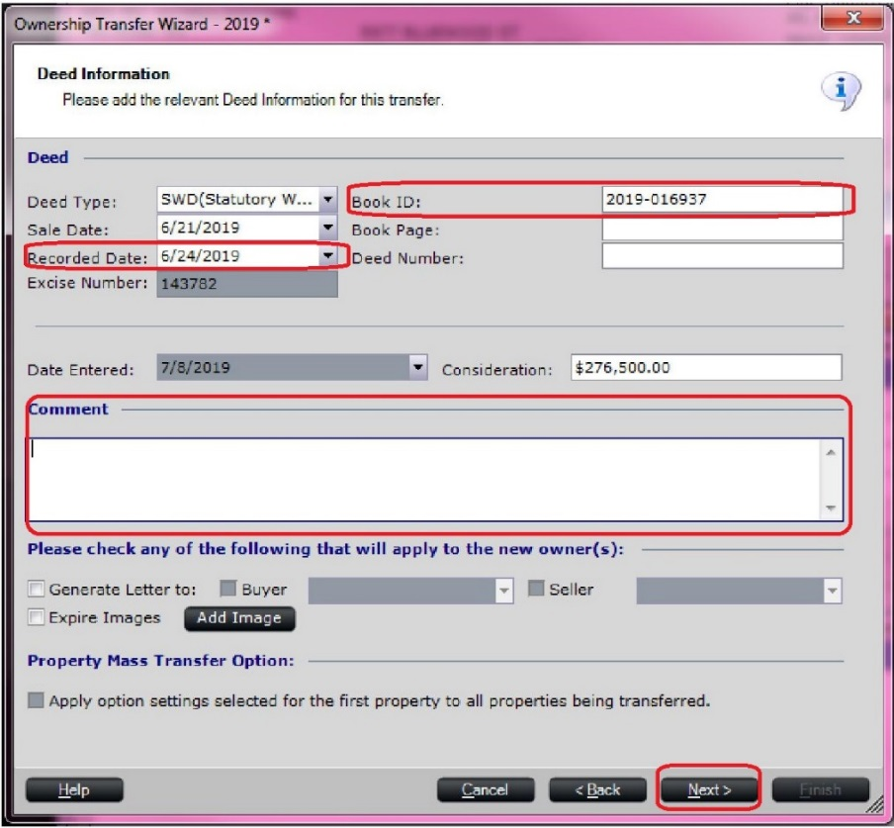

Comment Examples:

If the buyer’s name is followed by special instructions, enter the instructions in the Comment field.

* Joint tenants
* Husband and wife,
* Tenants in common
* Right of survivorship
* Life estate reserved for _______
* Creating community property
* Creating separate property
* Removing deceased spouse
* List if any linked owners

1. The Ownership History screen will pop up. If there are multiple properties associate with this deed, you can add all properties by clicking the properties panel, clicking the green plus sign under properties and adding all related PIDs. (all the info will have to be checked on individual level of each parcel before linking them) If there is only one property (or after you have added all associated properties) you will open the Sales Information Panel. Using the drop downs select the respective Sale Type and Ratio Code using the lists provided (See Exhibit B for sale type and Ratio Codes). If the parcel is land only (no improvement value) as noted on the side of the deed copy, check the box called ‘Land Only Sale’. Click Apply. Click OK. If there are multiple parcels associate with this transaction, see Exhibit A, step 1.

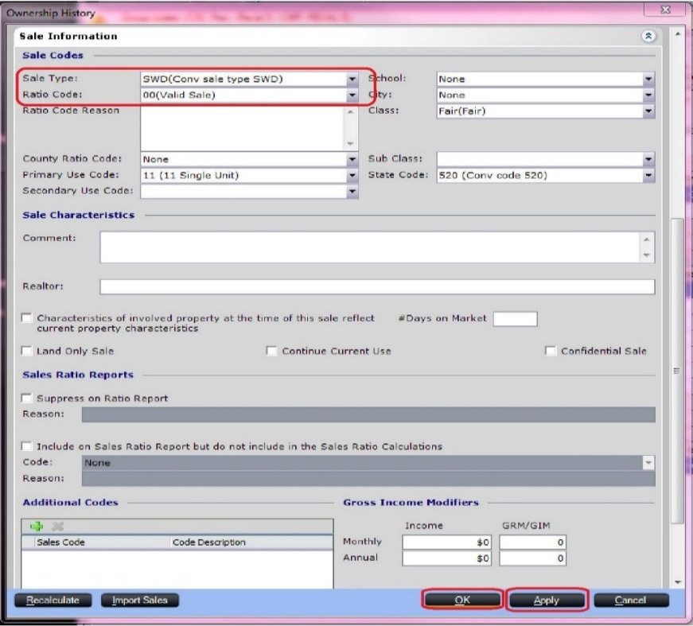

**Exhibit A**

1. If you had multiple parcels associated to your deed, even though you have added them to the Ownership Transfer, you will still need to go into each additional parcel and Set Taxpayer.

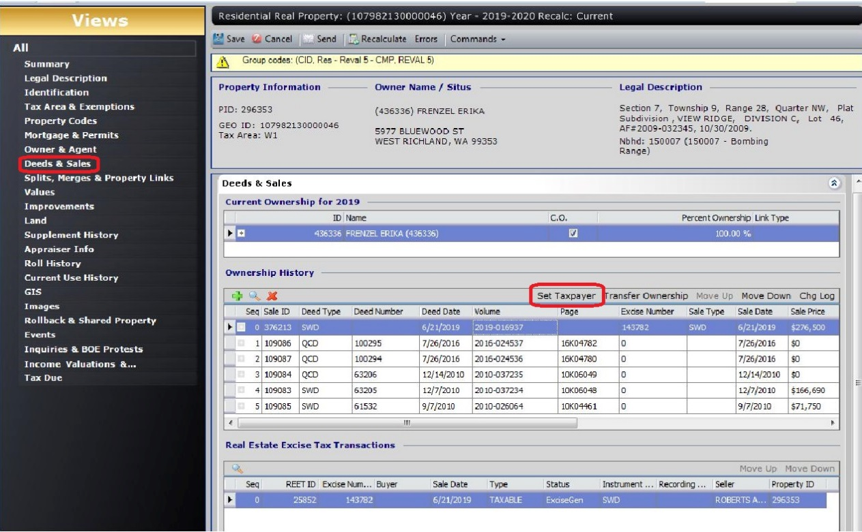

1. If you put a deed in the Check Legal folder, BLA1 folder, or if there are other corrections that need to be made before the transfer can be completed, you will need to add the respective group code to all related parcels. To do this, go to the parcel(s) involved, go to the Property Codes panel, click the green plus sign under Property Group Codes and choose the respective code. For check legal it is PENDING CHECK LEGAL. For BLA it is PENDING BLA. For any other corrections needed it is ASR IN REVIEW. For Check Legal and Assessor Review, there is a spreadsheet located at G:\Clerical\Deed Technician\BLA\Check Legal to track all of these deeds and any contact or corrections made. Also, leaving event note AF# and note why its rejected. (See exhibit C, step 2 for more detailed guide)

**Exhibit B**

Types of Deeds and Ratio Codes

Statutory Warranty Deed

Warranty Deed/ Statutory Warranty Deed - 00

If the value in pacs is only for land but the sale price includes the new home – in the box leave a comment “**LAND & HOME BUNDLE, HOME NOT VALUED YET”.**

Quit Claim Dee/ Lack of Probate – MISC - 9

* Quit Claim,
* These are usually adding or removing an owner or name change, not usually a sale

Bargain and Sale Deed / Special Warranty Deed/ Real Estate Contract - 27

* Choose other and note in Ratio Code Reason “Bargain and Sale Deed”
* Choose other and note in Ratio Code Reason “Special Warranty Deed”

Trustee’s Deed - 4

* Always choose Receiver or Trustee in bankruptcy

Sheriff’s Deed - 5

* Choose Sheriff or Bailee

Fulfillment Deed – we don’t transfer these

Transfer on Death Deed – we don’t transfer these until death cert is recorded. Ration 9

Water Deed/Mineral Deed

* You will not complete anything on these. There will not be an Excise.

Personal Representatives Deed - 3

* Choose Administrator, Guardian, or Executor of an Estate

Notice of Trustee’s Sale

* You will not need to proceed with this. It is only notifying of the sale that will take place at a later date. After it is auctioned off, you will see a Trustee’s Deed come through

Lack of Probate Affidavit or LOP – 9

* Most used in cases of a deceased owner whose estate has not been processed in court. A copy of an official certificate of death and a list of heirs – as well as their relationship to the deceased – should be provided. Ownership will transfer to all heirs listed. This document is used when other sources of verification are not available (ie court orders, community property agreements etc)

**Exhibit C**

**INFORMATION TO KNOW**

1. After processing a Government Transfer, or if grantor or grantee is non profit – save this deed to: G:\Clerical\Deed Technician\Government Transfers

**ASSESSOR IN REVIEW AND CHECK LEGAL:**

1. **Discrepancies in Ownership:**

If ownership in PACS does not match the deed (see G:\Clerical\Deed Technician\Procedures\Summary of Deed Questions 2021 for clarification), **DO NOT TRANSFER,** then follow these steps:

* 1. Group code this parcel with “ASSESSOR IN REVIEW”.
  2. Make an event note (ASSESSOR IN REVIEW). Date - detail exactly what the discrepancy is - initials. Copy this note as you’ll need it later when in the Check Legal Spreadsheet.
  3. Go to Check Legal Spreadsheet - G:\Clerical\Deed Technician\Check Legal\Check Legal - Status – fill out all information. In “Notes” section, this is where you’ll paste your PACS event note.
  4. Send letter to Grantor and/or Grantee. You can find sample letters here: G:\Clerical\Deed Technician\Letters. Save your letter to this folder. Save as PID/Taxpayer Name/Initials.
  5. After deed is re recorded and transferrable:
     1. Make note in transfer stating how this was resolved, ie: “AFxxxx-xxxxxx re record of AFxxxx-xxxxxx to correct (write situation) – initials”.
     2. Go to event note and make new note above, “date – resolved – initials”.
     3. Remove “ASSESSOR IN REVIEW” group code.
     4. Remove from Check Legal Spreadsheet.

1. **Discrepancies in Legal Description:**
   1. If you are unsure if legal on deed is describing same parcel as PACS, review previous deeds to see if this same legal has been transferred before. If still unsure, **DO NOT TRANSFER,** then follow these steps:
      1. Group code this parcel with “Pending Check Legal”.
      2. Write on deed exactly what part of legal you are questioning. This helps the segregation department when reviewing. Save deed to Check Legal folder - G:\Clerical\Deed Technician\Check Legal. Save it as the parcel#.
      3. Make an event note (PENDING CHECK LEGAL). “Date - detail exactly what the discrepancy is and what you’re questioning - initials”. Copy this note as you’ll need it later when in the Check Legal Spreadsheet.
      4. Go to Check Legal Spreadsheet - G:\Clerical\Deed Technician\Check Legal\Check Legal - Status – fill out all information. In “Notes” section, this is where you’ll paste your PACS event note.
      5. Do not send letter or transfer until you have clarification from the segregation department. Every so often, you’ll want to check back to the Check Legal folder and check the Legal Correct & Legal Incorrect folders. This is where the segregation department will put deeds after review.
         1. If segregation department says legal is **correct**:
            1. Make note in transfer stating how this legal was reviewed by seg dept and is okay to transfer, ie: “Legal was reviewed by seg dept, okay to transfer – initials”.
            2. Go to event note and make new note above, “date – resolved – initials”.
            3. Remove “PENDING CHECK LEGAL” group code.
            4. Remove from Check Legal Spreadsheet.
            5. Remove (delete) saved deed from Legal Correct folder.
         2. If segregation department says legal is **incorrect**, follow steps below in bullet point (b.)
            1. Remove (delete) saved deed from Legal Incorrect folder.
   2. If you are absolutely sure the legal description on the deed is incorrect, **DO NOT TRANSFER**, then follow these steps:
      1. Group code this parcel with “Pending Check Legal”.
      2. Make an event note (PENDING CHECK LEGAL). “Date - detail exactly what the discrepancy is - initials”. Copy this note as you’ll need it later when in the Check Legal Spreadsheet.
      3. Go to Check Legal Spreadsheet - G:\Clerical\Deed Technician\Check Legal\Check Legal - Status – fill out all information. In “Notes” section, this is where you’ll paste your PACS event note.
      4. Send letter to Grantor and/or Grantee. You can find sample letters here: G:\Clerical\Deed Technician\Letters. Save your letter to this folder. Save as PID/Taxpayer Name/Initials.
      5. After deed is re recorded and transferrable:
         1. Make note in transfer stating how this was resolved, ie: “AFxxxx-xxxxxx re record of AFxxxx-xxxxxx to correct (write situation) – initials”.
         2. Go to event note and make new note above, “date – resolved – initials”.
         3. Remove “PENDING CHECK LEGAL” group code.
         4. Remove from Check Legal Spreadsheet.